# Viewing our Web Pages

The following is an example of how to upload files to your UAlbany web server area. You will need an FTP client and a file (preferably HTML) to start this process. I would personally recommend FileZilla as it is free and used in the demonstration below.

Open FileZilla and use the left panel (Local site) to navigate to the folder which contains your HTML file. In my case, I will be uploading a very basic example.html file that only contains an h1 tag with the phrase “Hello World!” The screenshot below depicts what your FileZilla client will look like once you navigate to the folder with the file you want to upload.

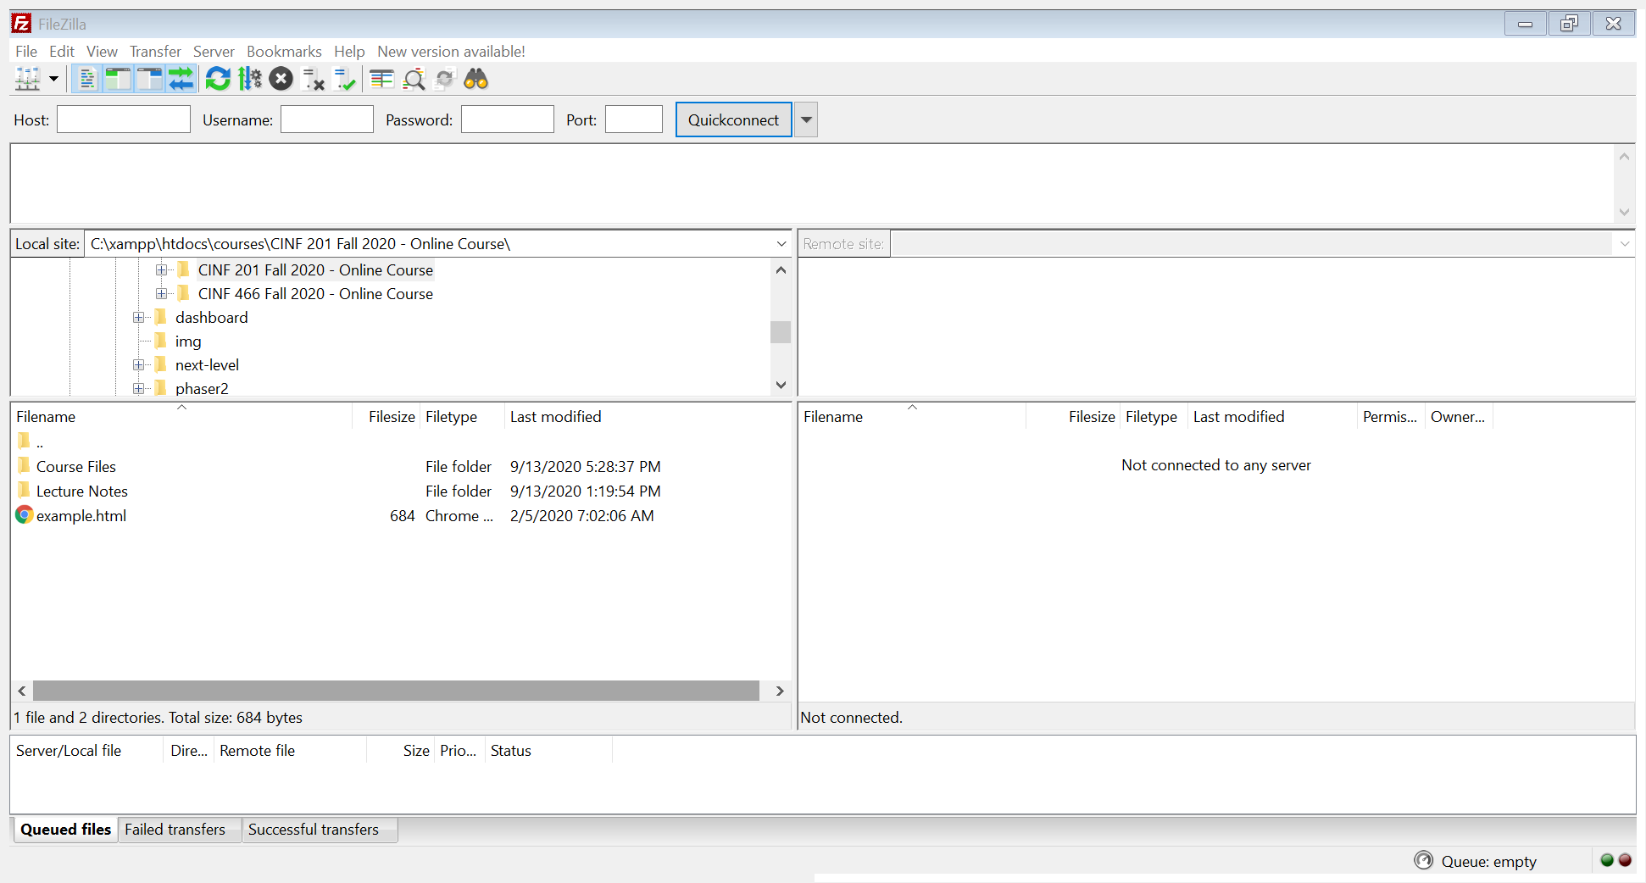

After successfully navigating to the folder with your file, your next step is to login to the web server area. To do so, you will need to type in the following credentials into the Host, Username, and Password areas:

Host: sftp://perspub.albany.edu

Username: Your NetID that you normally use to sign in to UAlbany services (**your NetID must be lowercased or it will fail to authenticate**).

Password: The password associated with your UAlbany NetID

After you have entered your credentials, click “Quickconnect” and this will open the web server for you (on the Remote site side). If you have never connected to your web server for another course, it should contain no folders or files. I would recommend creating a “cinf201” folder to keep your content organized. You can simply right-click on the side of the web server and select, “Create directory.” I have included a screenshot below which depicts what this will look like when you are done creating the folder.

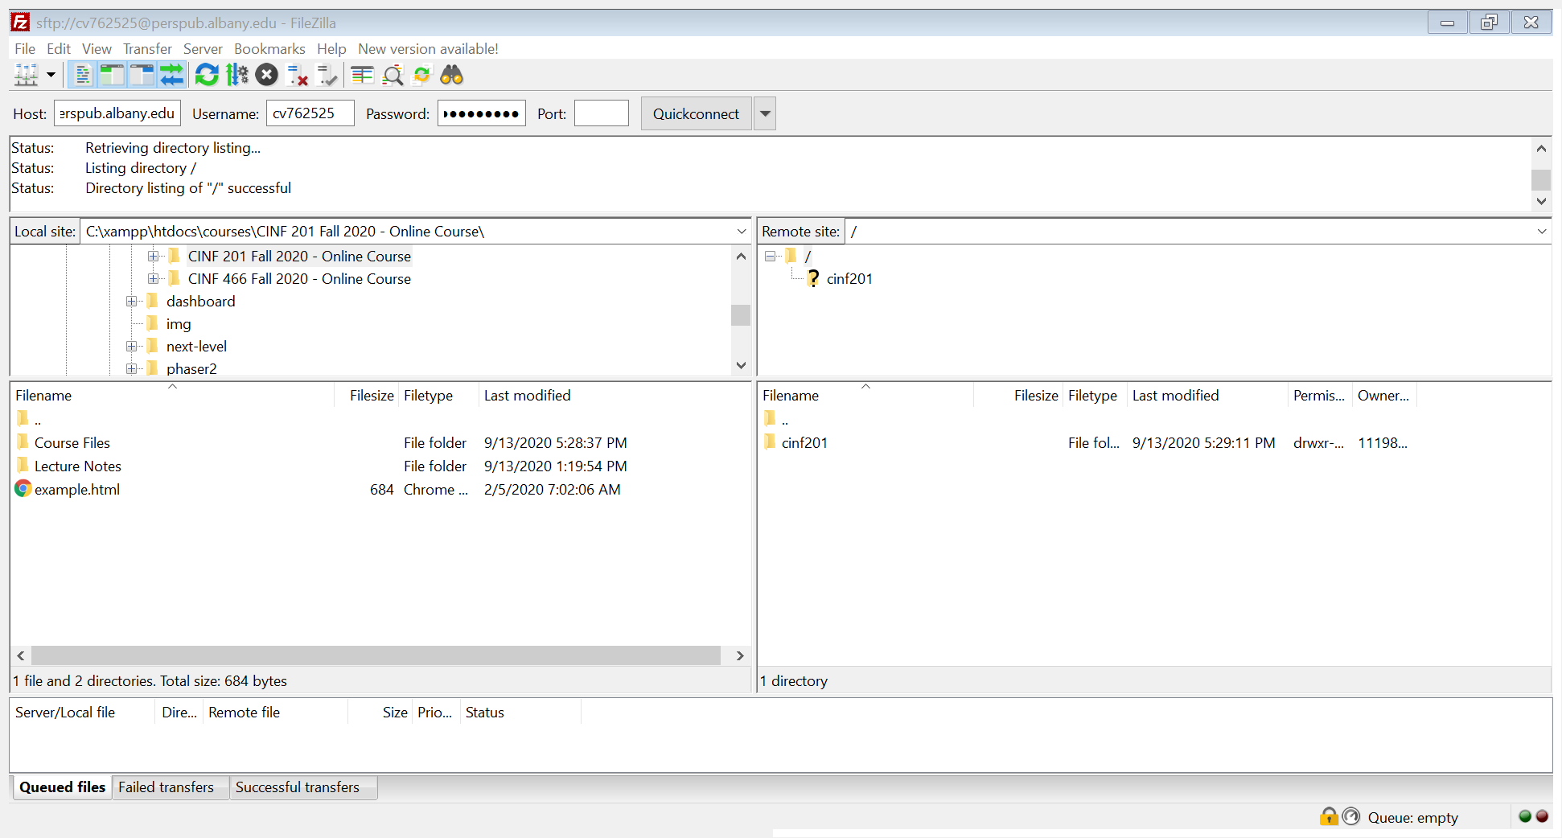

After creating your folder, uploading a file is as simple as double-clicking the file on the left side or you can click/drag it over from the left pane to the right pane. In my example, I will be copying the example.html file into the cinf201 folder which is depicted below.

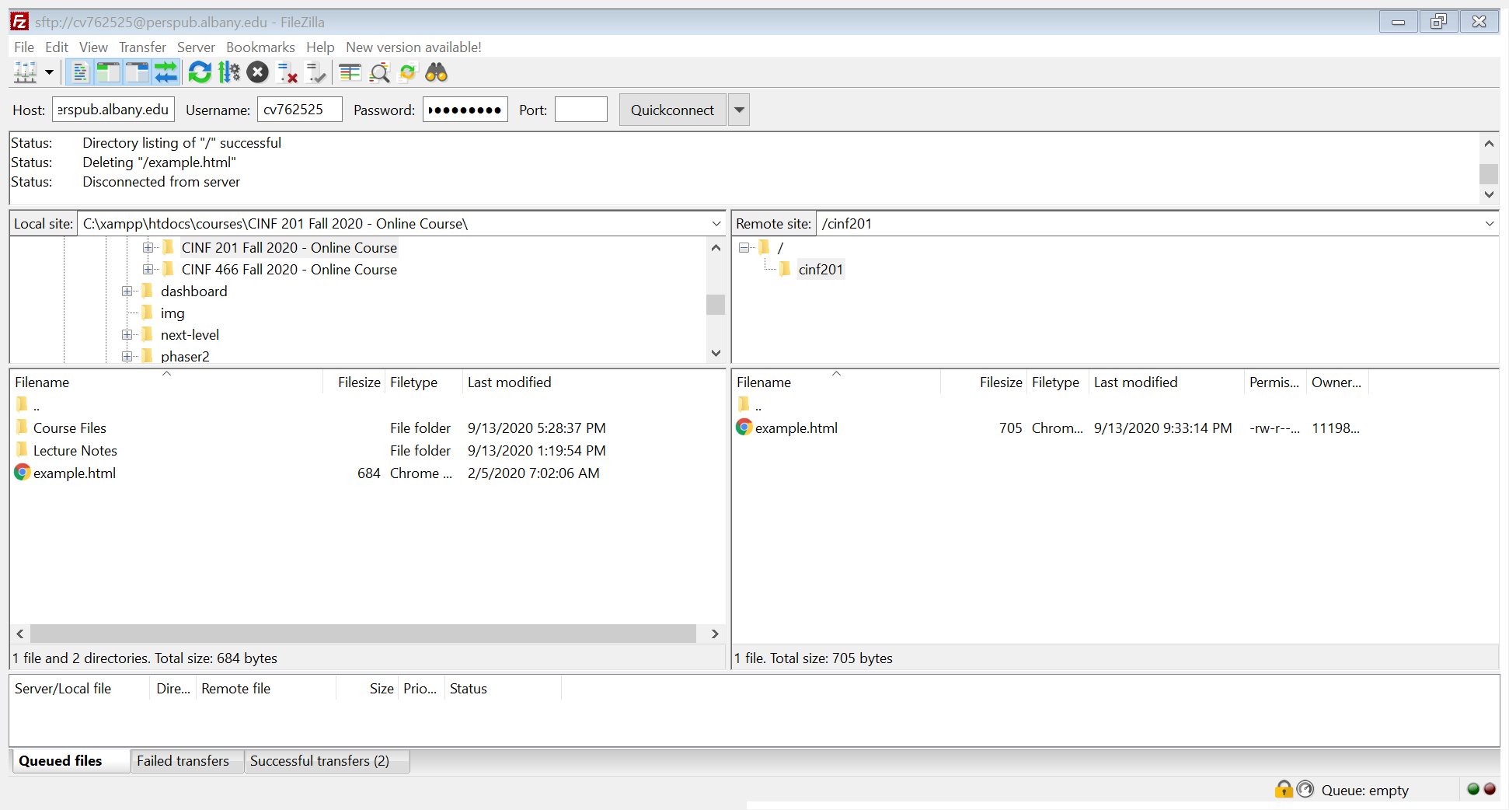

Once your file has successfully transferred, you can figure out the link to your file by using your UAlbany NetID. The link will always start with the following: Albany.edu/~username/

You would replace username with the NetID you use to sign in to your UAlbany services. In my case, the link is going to look like the line below. This will be considered a live link for our purposes and your assignment submissions should look similar.

<https://www.albany.edu/~cv762525/cinf201/example.html>

I would strongly recommend creating weekly folders for your assignments, so it is easy to keep track of them. After week 3, ALL assignments which involve coding should be submitted as a live link so I can easily click the link and see your work. If you use image files or any other files in your HTML page, they should be uploaded, and the file/folder structure you use locally should be duplicated on the web server as well.